

**A Project Report**

on

**CrimeGuard**

submitted as partial fulfillment for the award of

**BACHELOR OF TECHNOLOGY**

**DEGREE**

SESSION 2024-25

in

**Computer Science and Engineering (Artificial Intelligence & Machine Learning)**

By

Shreya Goswami (2100291530051)

Khushi Bansal (2100291530028)

Mahi Tyagi (2100291530031)

**Under the supervision of**

Mr Rajeev Kumar Singh

**KIET Group of Institutions, Ghaziabad**

Affiliated to

**Dr. A.P.J. Abdul Kalam Technical University, Lucknow**

(Formerly UPTU)

**Feb, 2025**

**DECLARATION**

We hereby declare that this submission is our own work and that, to the best of our knowledge and belief, it contains no material previously published or written by another person nor material which to a substantial extent has been accepted for the award of any other degree or diploma of the university or other institute of higher learning, except where due acknowledgment has been made in the text.

Signature

Name:

Roll No.:

Date:

## CERTIFICATE

This is to certify that Project Report entitled “CrimeGuard” which is submitted by Student name in partial fulfillment of the requirement for the award of degree B. Tech. in Department of CSE(AIML) of Dr. A.P.J. Abdul Kalam Technical University, Lucknow is a record of the candidates own work carried out by them under my supervision. The matter embodied in this report is original and has not been submitted for the award of any other degree.

**Mr Rajeev Kumar Singh**  **Dr. Rekha Kashyap**

**(Designation) (Head of Department)**

**Date:**

ACKNOWLEDGEMENT

It gives us a great sense of pleasure to present the report of the B. Tech Project undertaken during B. Tech. Final Year. We owe special debt of gratitude to Mr Rajeev Kumar Singh, Department of CSE(AIML), KIET, Ghaziabad, for his constant support and guidance throughout the course of our work. His sincerity, thoroughness and perseverance have been a constant source of inspiration for us. It is only his cognizant efforts that our endeavors have seen light of the day.

We also take the opportunity to acknowledge the contribution of Dr. Rekha Kashyap, Head of the Department of Computer Science & Engineering, KIET, Ghaziabad, for his full support and assistance during the development of the project. We also do not like to miss the opportunity to acknowledge the contribution of all the faculty members of the department for their kind assistance and cooperation during the development of our project.

We also do not like to miss the opportunity to acknowledge the contribution of all faculty members, especially faculty/industry person/any person, of the department for their kind assistance and cooperation during the development of our project. Last but not the least, we acknowledge our friends for their contribution in the completion of the project.

Date:

Signature:

Name :

Roll No.:

**ABSTRACT**

CrimeGuard is a comprehensive system designed for predictive crime analysis and real-time violence detection using Machine Learning and Computer Vision. The project aims to enhance public safety by leveraging historical crime data to predict potential crime hotspots and utilizing real-time video analysis to detect violent activities. The system integrates deep learning models, such as VGG16 for feature extraction and custom-trained neural networks, to identify violent behavior from surveillance footage. Additionally, ARIMA-based predictive modeling is employed to analyze crime trends and forecast future crime rates. The platform features an interactive dashboard for crime data visualization, helping law enforcement agencies make data-driven decisions. Built with Flask for the backend and HTML, CSS, JavaScript for the frontend, CrimeGuard provides an efficient and scalable solution to assist in crime prevention and response.

|  |  |
| --- | --- |
| **TABLE OF CONTENTS** | **Page No.** |
| DECLARATION……………………………………………………………………. | ii |
| CERTIFICATE……………………………………………………………………… | iii |
| ACKNOWLEDGEMENTS…………………………………………………………. | iv |
| ABSTRACT………………………………………………………………………..... | v |
| LIST OF FIGURES…………………………………………………………………. | ix |
| LIST OF TABLES…………………………………………………………………… | xi |
| LIST OF ABBREVIATIONS………………………………………………………. | xii |
| CHAPTER 1 (INTRODUCTION)…………………………………………………. | 1 |
| 1.1. Introduction……………………………………………………………………... | 1 |
| 1.2.  Project Description………………………………………………………………  1.3.Problem Statement……………………………………………………………….  1.4.Existing System………………………………………………………………….  1.5.User  Requirement Analysis………………………………………………………  1.6.Feasibility Study…………………………………………………………………. | 1  1  1  1  1 |
| CHAPTER 2 (LITERATURE REVIEW)…………………………………………. | 2 |
| 2.1.Literaturereview…… …………............................................................................. | 2 |
| 2.2. Research Gap .…................................................................................................ | 2 |
|  |  |
| CHAPTER 3 (PROPOSED METHODOLOGY) ….................................................. | 3 |
| 3.1. Methodology ……................................................................................................  3.2.Dataset…………………………………………………………………………..  3.3.Pre-Processing…………………………………………………………………..  3.4.Dataset Split…………………………………………………………………….  3.5.Model Architecture……………………………………………………………..  3.6Hyperparameter Tuning………………………………………………………….  3.7.Model Training………………………………………………………………….  3.8Model Prediction and Visualization……………………………………………….  3.9.Tech Stack………………………………………………………………………...  3.10.Use Case Model…………………………………………………………………  3.11.Training and Testing…………………………………………………………….  3.12.Sequence Diagram………………………………………………………………  3.13.System Architecture……………………………………………………………. | 3  3  3  3  3  3  3  3  3  3  3  3  3 |
| CHAPTER 4 (RESULTS AND DISCUSSION) ........................................................  4.1.Results……………………………………………………………………………  4.2.Observations……………………………………………………………………..  4.3.Conclusion……………………………………………………………………….. | 4  4  4 |
| CHAPTER 5 (CONCLUSIONS AND FUTURE SCOPE).................................. | 5 |
| 5.1. Conclusion...................................................................................................... | 5 |
| 5.2. Future Scope................................................................................................... | 5 |
|  |  |
| REFERENCES………………………………………………………………………. | 6 |
| APPENDEX1………………………………………………………………………... | 7 |
|  |  |
|  |  |
|  |  |
|  |  |
|  |  |
|  |  |
|  |  |
|  |  |
|  |  |

**LIST OF FIGURES**  
  
Figure No. Description Page No.  
Figure 1 Dataset Split 10  
Figure 2 Preprocessing Pipeline 11  
Figure 3 Use Case Diagram 18  
Figure 4 Training Workflow 19  
Figure 5 Testing Workflow 20  
Figure 6 Sequence Diagram 21  
Figure 7 System Architecture 22  
Figure 8 Model Accuracy 23  
Figure 9 Loss Curves of CNN+LSTM 24  
Figure 10 ROC Curve 25  
Figure 11 Home Page 26  
Figure 12 Our Services 27

|  |  |  |
| --- | --- | --- |
|  |  |  |
|  |  |  |

**LIST OF TABLES**

|  |  |  |
| --- | --- | --- |
| **Table. No.** | **Description** | **Page No.** |
| 1.1 | Performance metrics for violence detection models | 22 |

**LIST OF ABBREVIATIONS**

**Abbreviation** **Full Form**

CNN Convolutional Neural Network

BiLSTM Bidirectional Long Short-Term Memory

ReLU Rectified Linear Unit SMTP Simple Mail Transfer Protocol

GPU Graphics Processing Unit

IDE Integrated Development Environment

VGG Visual Geometry Group

RNN Recurrent Neural Network

RLVS Real-Life Violence Situation

**CHAPTER 1**

**INTRODUCTION**

**1.1 Overview**

In today’s rapidly evolving digital landscape, law enforcement and security agencies face significant challenges in crime prevention and real-time threat detection. Traditional surveillance methods and manual monitoring often prove inefficient, leading to delayed responses and missed critical incidents. Additionally, analyzing vast amounts of crime data to identify patterns and predict potential threats remains a complex task.

CrimeGuard focuses on enhancing public safety by automating real-time violence detection and predictive crime analysis. The system processes video feeds using a trained CNN+BiLSTM model to detect violent activities and trigger real-time alerts. Additionally, it integrates crime prediction models to analyze historical crime data and identify high-risk areas. Comparative analysis with models like VGG16 and ResNet ensures the effectiveness of the proposed architecture. The system reduces reliance on manual surveillance, providing a faster, more accurate response to security threats while offering insights into crime patterns through an interactive visualization module.

**1.2 Project Description**

CrimeGuard is an AI-powered system designed to enhance public safety by combining predictive crime analysis with real-time violence detection. Using machine learning techniques, it analyzes historical crime data to identify patterns and predict high-risk areas. Simultaneously, it employs deep learning-based computer vision to monitor live video feeds, detecting violent activities such as assaults and fights. Upon detecting suspicious behavior, the system triggers automated alerts, ensuring a swift response from law enforcement.

The system is built using OpenCV for image processing and video analysis, TensorFlow for deep learning-based violence detection, and Scikit-learn for crime pattern analysis and predictive modeling. The frontend is developed with React, offering an interactive dashboard where law enforcement agencies can visualize crime trends, analyze historical data, and receive real-time notifications. CrimeGuard’s intelligent approach enables proactive crime prevention, improving resource allocation and response times.

By integrating machine learning, deep learning, and real-time video monitoring, CrimeGuard provides an efficient, scalable, and high-impact solution for crime detection and prevention. Its AI-driven insights and automated alert system help law enforcement make data-driven decisions, ensuring safer communities and more effective crime management strategies.

**1.3 Problem Statement**

Crime detection and prevention remain significant challenges due to the limitations of manual surveillance and delayed response times. Current systems struggle with real-time detection, diverse environmental conditions, and predictive crime analysis. There is a need for an efficient solution that can:

Process live video feeds to identify violent activities. Predict high-crime areas based on historical data trends. Send instant notifications to authorities for quick intervention. Visualize crime insights interactively for better decision-making. By addressing these gaps, CrimeGuard ensures faster response times, improved situational awareness, and proactive crime prevention.

**1.4 Existing System**

Current crime detection and prevention methods rely on manual monitoring or rule-based techniques, which suffer from the following limitations:

Human Error – Surveillance personnel experience fatigue, leading to missed incidents.

Delayed Response – Lack of automation results in slow reaction times.

Limited Predictive Analysis – Most systems do not utilize historical data to forecast crime trends.

Lack of Real-Time Alerts – Traditional systems fail to provide instant notifications, reducing emergency response efficiency.

Insufficient Visual Analysis – Many systems lack advanced deep learning models for robust video analysis.

These limitations highlight the need for an automated, AI-driven system capable of detecting violence, predicting crime patterns, and ensuring timely interventions.

**1.5 User Requirement Analysis**

CrimeGuard is designed to meet the following requirements:

❖ Functional Requirements:

Real-time video processing for violence detection.

High-accuracy differentiation between violent and non-violent activities.

Crime prediction module to analyze historical trends and forecast high-risk locations.

Instant alerts sent to concerned authorities via email, including incident details, timestamp, and image evidence.

Visualization module displaying real-time crime trends through interactive dashboards.

❖ Non-Functional Requirements:

Compatibility with existing CCTV and surveillance systems.

Scalability to handle multiple live video streams simultaneously.

Low latency to ensure timely detection and alerts.

Secure data handling in compliance with privacy regulations.

❖ End-User Needs:

Seamless integration with current surveillance infrastructure.

User-friendly interface with automated alert mechanisms.

Minimal false positives to enhance reliability.

**1.6 Feasibility Study**

Technical Feasibility:

CrimeGuard is built using CNN+BiLSTM for visual analysis and ML-based prediction models for crime forecasting. Flask framework ensures a lightweight and scalable deployment. SMTP-based email notifications provide real-time updates to security personnel.

Economic Feasibility:

Uses open-source tools (TensorFlow, OpenCV, Flask, Scikit-learn), minimizing costs. Leverages existing surveillance infrastructure, reducing deployment expenses.

Operational Feasibility:

User-friendly design, requiring minimal technical expertise for operation. Automated alerts and crime insights, enhancing law enforcement response efficiency.

Legal Feasibility:

Adheres to data privacy regulations, ensuring secure local processing of video feeds. Complies with ethical AI guidelines to prevent misuse of surveillance data.

Schedule Feasibility:

The project is feasible within the proposed timeline, as it uses readily available datasets and pre-trained models for accelerated development.

**CHAPTER 2**

**LITERATURE REVIEW**

**2.1 Literature Review**

Recent advancements in violence detection systems have demonstrated significant improvements in real-time monitoring, scalability, and computational efficiency. Convolutional Neural Networks (CNN) and convolutional Long Short-Term Memory (LSTM) models have been widely used to extract spatio-temporal features from surveillance videos, achieving high accuracy by analyzing frame-level differences to identify violent events [1][13]. Lightweight architectures such as MobileNetV2, ResNet, and MobileNet-TSM integrate spatial and temporal feature extraction, offering solutions that are computationally efficient and suitable for deployment in resource constrained environments [6][7][8][9]. Hybrid methodologies combining handcrafted features with deep transfer learning models like Xception and 2D CNNs have proven effective in classifying violent and non-violent behaviors, particularly in public datasets like HBD21 [4][11]. Advanced spatio-temporal frameworks, including 3D CNNs and Motion Saliency Maps (MSM) integrated with Temporal Squeeze-and-Excitation (T-SE) modules, outperform traditional models by providing state-of-the-art results on benchmark datasets such as Hockey Fight and Crowd Violence [3][5]. Deep learning architectures such as ViolenceNet and multi-stream networks, which incorporate DenseNet, multi-head self-attention, and bidirectional LSTMs, enhance the detection of person to person violence. However, challenges persist in generalizing these models across diverse datasets [10][12]. Furthermore, motion blob-based techniques have been introduced to prioritize computational speed over accuracy, making them practical for real-time applications in high-risk settings like prisons and psychiatric centers [14]. Complementing these approaches, CNN models capable of detecting objects such as knives and guns have shown potential in predicting crime scenes with high accuracy, thereby ensuring reliable alerts and enhancing public safety measures [15]. These findings underscore the progress in developing intelligent surveillance systems capable of addressing real-world constraints while maintaining high accuracy and real-time responsiveness.  
  
**2.1 Research Gap**

Dataset Diversity: Current studies rely on specific datasets, limiting the ability of models to generalize to real-world violence detection. Models often perform well on standard datasets but struggle with varied environments.

• Real-World Challenges: Models often struggle with varied real-world conditions such as different lighting, crowd sizes, and motion patterns, which affect the accuracy and robustness of violence detection systems.

• False Positives: High rates of misclassification, especially in complex environments like sports or crowded spaces, result in significant false positives, reducing the reliability of the detection system.

• Limited Dataset Size: Many models rely on small datasets, which reduces their generalizability and limits their ability to perform well in diverse real-world scenarios.

• Integration with Safety Systems: Few studies address the integration of violence detection models with real-time alert systems and automated responses, which are critical for preventing incidents and ensuring safety.

• Real-Time Constraints: Existing models often face challenges with real-time processing, balancing the need for high accuracy with computational efficiency, especially in resource constrained environments.These gaps highlight critical areas for improvement in developing more robust and practical violence detection systems.

**CHAPTER 3**

**PROPOSED METHODOLOGY**

**3.1 Methodology**

To address the growing need for real-time crime detection in surveillance systems, we implemented a structured approach that combines advanced deep learning techniques with practical application strategies. The aim is to develop a robust and efficient system capable of accurately identifying violent activities from both recorded videos and live feeds while ensuring timely intervention. Additionally, the system includes predictive analysis for identifying potential crime hotspots based on historical data and a visualization module for presenting insights interactively.

The proposed solution integrates Convolutional Neural Networks (CNNs) for extracting spatial features from video frames and Bidirectional Long Short-Term Memory (BiLSTM) networks for capturing temporal patterns across sequences of frames. This hybrid architecture enables the system to process video data comprehensively, leveraging the strengths of both spatial and temporal analysis. Furthermore, predictive crime analysis is incorporated using historical crime data and machine learning models to forecast crime-prone areas. The visualization module presents real-time crime activity trends and model predictions using interactive dashboards. The following sections detail the key steps, including dataset preparation, model design, training, evaluation, real-time implementation, and visualization. This systematic approach ensures that the system is adaptable to varied real-world conditions and can reliably assist in enhancing public safety.

**3.2 Dataset**

The dataset used for this project comprises a total of 2,000 videos, evenly divided into two categories: Non-Violence and Violence. The Non-Violence category includes 1,000 videos representing real-life situations such as sports activities, singing, vlogging, eating, and movie scenes. These videos are diverse and showcase non-violent human behaviors to help the model distinguish them accurately from violent actions. The Violence category contains 1,000 videos depicting activities like street fights, sports fights, and movie fight scenes. This directory focuses on capturing various forms of violent behavior in real-world settings to ensure the model can generalize across different environments and contexts. The balanced and diverse nature of the dataset enhances the model's training, enabling it to effectively differentiate between violent and non-violent behaviors while minimizing false classifications. Additionally, a crime dataset containing historical crime records is used for predictive analysis, providing insights into crime trends based on time and location.

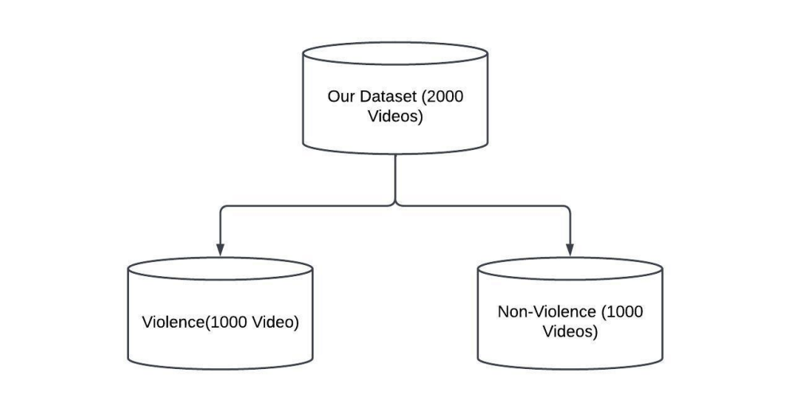Figure 1: Dataset Split

**3.3 Pre-processing**

The pre-processing of the video dataset is a crucial step in preparing the data for model training. The process begins with reading the input videos using OpenCV, ensuring compatibility with various formats. Each video is then split into individual frames, allowing the capture of temporal patterns essential for analyzing activities. The extracted frames are resized to a fixed dimension of (64 × 64) pixels to ensure uniformity and reduce computational complexity. Subsequently, the pixel values of the frames are normalized to maintain a consistent range, facilitating faster and more stable model convergence. The frames are then grouped into batches of eight consecutive frames, flattened, and stored along with their corresponding one-hot encoded labels: [0, 1] for violence and [1, 0] for non-violence. For predictive analysis, crime data is pre-processed by handling missing values, normalizing numerical features, and encoding categorical variables to improve the model’s accuracy. The visualization component processes the data to generate heatmaps and graphical representations of crime trends. This systematic pre-processing pipeline ensures the dataset is organized and optimized for efficient training of the CNN-BiLSTM model and predictive analysis models.



Figure 2: Preprocessing Pipeline

**3.4 Dataset Split**

The dataset is split into 80% training data and 20% validation data. The training set contains 25,862 frames, while the validation set contains 6,466 frames. Each split is balanced with an equal distribution of real and fake videos. The crime dataset is also split similarly for training and evaluation of predictive models.

**3.5 Model Architecture**

The proposed crime detection system uses a hybrid architecture that combines Convolutional Neural Networks (CNN) for spatial feature extraction and Bidirectional Long Short-Term Memory (BiLSTM) networks for capturing temporal dependencies across video frames. The input to the model consists of sequences of 8 frames, each resized to (64 × 64 × 3) pixels (height, width, and RGB channels). Therefore, the input shape is ((8, 64, 64, 3)). The CNN layers extract spatial features by applying convolutions over these frames, allowing the model to learn important visual patterns such as movements, shapes, and textures. The output of these layers is a set of feature maps, which are then processed to capture temporal dependencies across the sequence of frames.

After the CNN layers, the feature maps are downsampled using MaxPooling3D layers to reduce both spatial and temporal dimensions, enabling the model to focus on the most important features and improve computational efficiency. The feature maps are reduced progressively through three pooling layers. These downsampled features are reshaped into a 2D tensor, preparing the data for sequential processing by the BiLSTM layer. The reshaped features are then passed into the BiLSTM layer, which captures the temporal dependencies between frames across the 8-frame sequence.

For crime prediction, a separate model is developed using machine learning techniques such as Random Forest and Gradient Boosting to analyze historical crime data and predict high-risk locations. The visualization module employs interactive graphs and dashboards to display real-time detections and predictive crime patterns.

**3.6 Hyperparameter Tuning**

ReLU activation is used in convolutional and dense layers, while the Sigmoid activation function is used for the output layer. The optimizer chosen is SGD, and categorical cross-entropy is used as the loss function. Grid search is applied to tune hyperparameters in the predictive model for better accuracy.

**3.7 Model Training**

The model is trained using the fit() function with a batch size of 8 for 12 epochs. Early stopping is implemented to prevent overfitting. The predictive model is also trained with historical crime data, optimizing parameters for better forecasting accuracy.

**3.8 Model Prediction and Visualization**

After training, the CNN-BiLSTM model uses the predict() function to classify new video sequences. For real-time crime detection, frames are continuously processed, and alerts are generated when violence is detected. Additionally, the predictive crime analysis model forecasts high-crime areas based on historical data trends. The visualization module provides real-time graphs, heatmaps, and live streaming of video analysis results. It also includes interactive tools that allow users to explore trends in crime patterns and predictions visually.

**3.9 Tech Stack**

❖ Programming Languages: Python 3, JavaScript, HTML, CSS

❖ Backend Frameworks: Flask

❖ IDEs: Google Colab, Jupyter Notebook, Visual Studio Code

❖ Machine Learning Tools: TensorFlow/Keras, OpenCV, Scikit-learn

❖ Email Service: SMTP

❖ Visualization Tools: Matplotlib, Seaborn, Plotly, Dash

This tech stack efficiently handles everything from machine learning model training to real-time video processing, predictive crime analysis, and interactive visualization, ensuring a comprehensive and user-friendly experience for crime monitoring and prevention.

**3.10 Use Case Model**

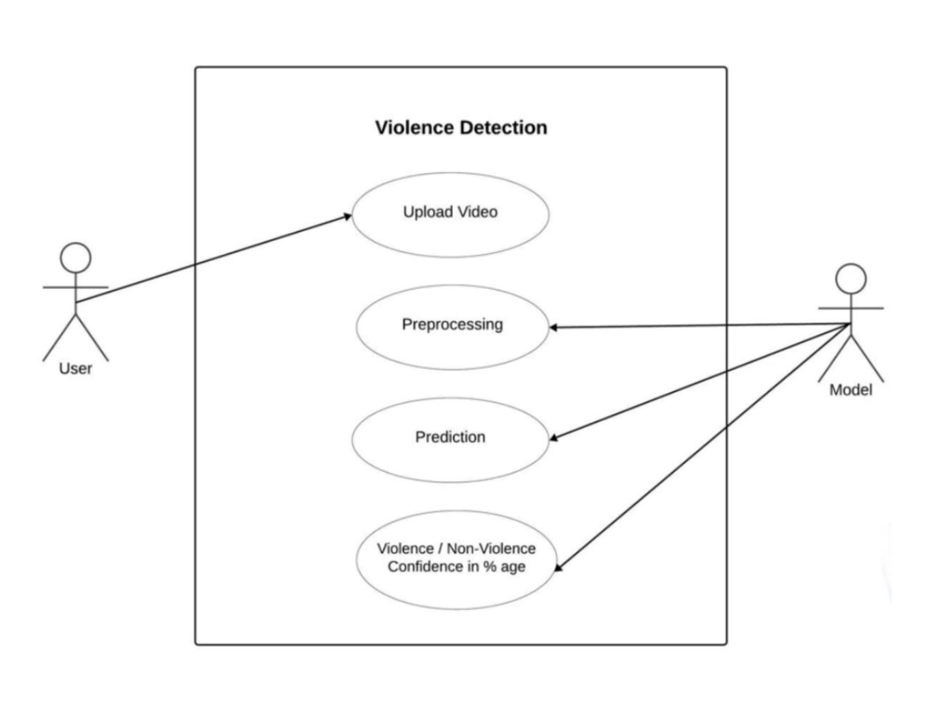Figure 3: Use case diagram

**3.11 Training and Testing**

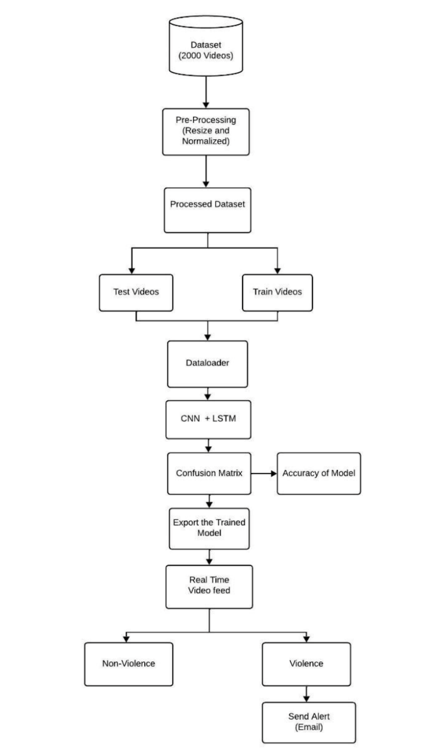

Figure 4: Training Workflow

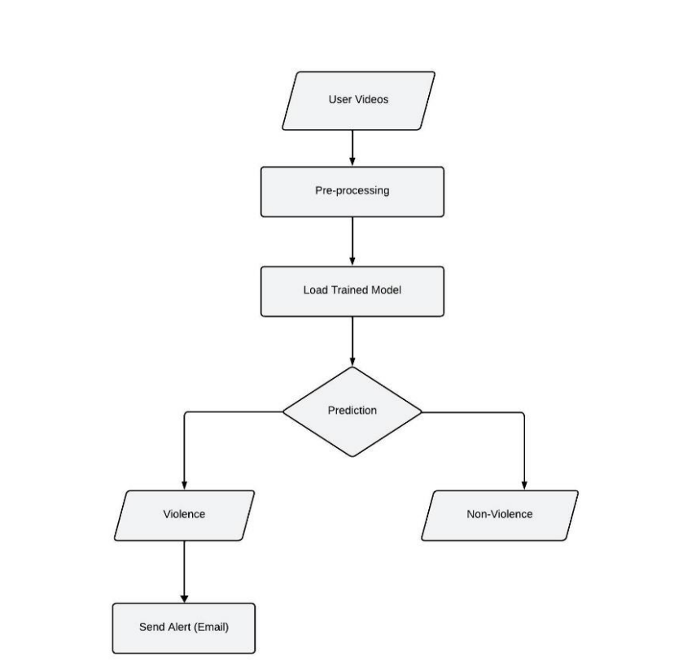

Figure 5: Testing Workflow

**3.12 Sequence Diagram**

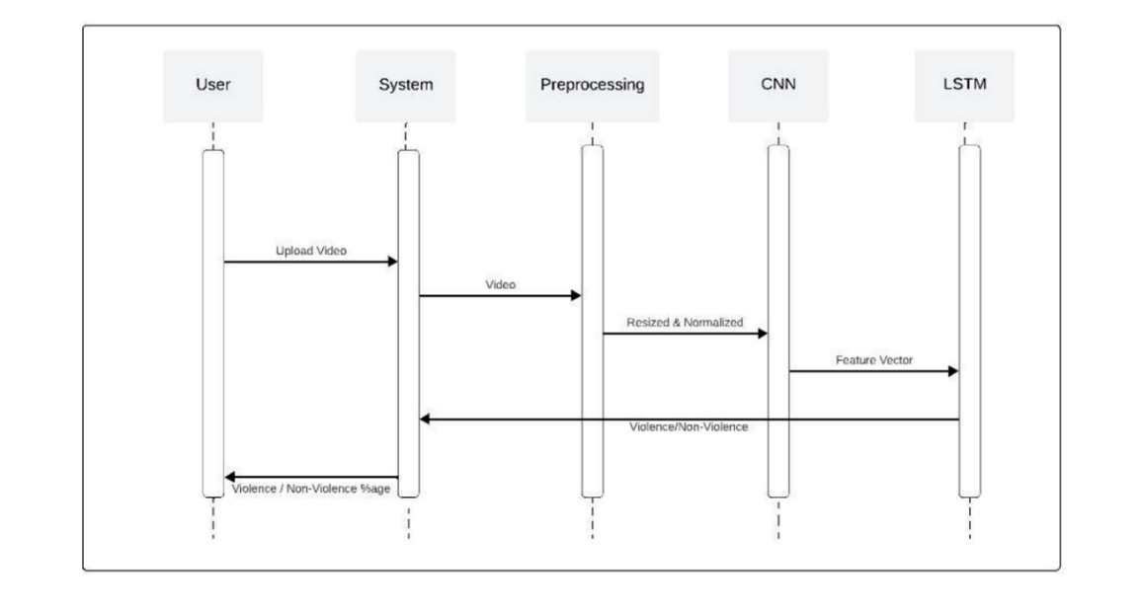

Figure 6: Sequence Diagram

**3.13 System Architecture**

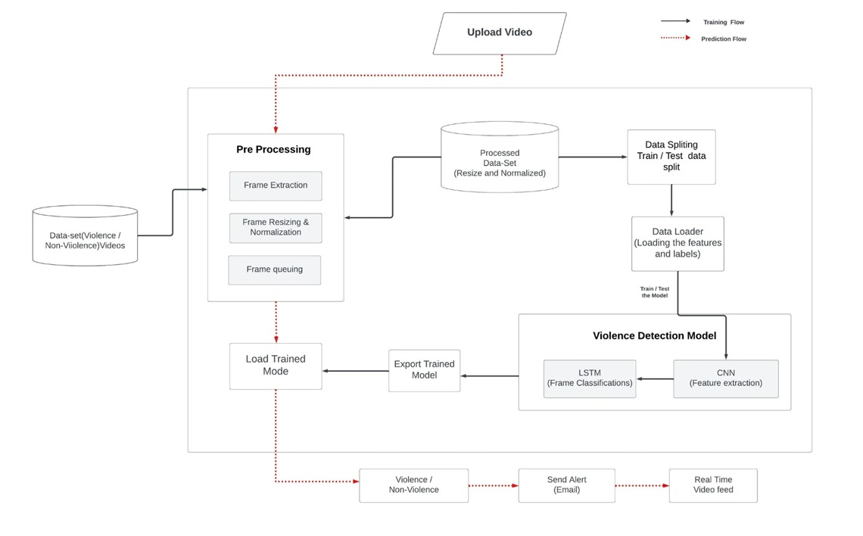

Figure 7: System Architecture

**CHAPTER 4**

**RESULTS AND DISCUSSION**

**4.1 Result**

The CrimeGuard system was evaluated on a dataset containing real-world surveillance footage and historical crime records. The model’s performance was assessed using key metrics such as accuracy, precision, recall, F1-score, and computational efficiency. The dataset included diverse video samples covering various violent and non-violent scenarios to ensure robust testing. All experiments were conducted using Python with libraries like TensorFlow, OpenCV, and Scikitlearn. A. Metrics Definition • Accuracy: Measures the percentage of correctly classified violent and non-violent incidents. • Precision: Represents the proportion of detected violent incidents that were actually violent, minimizing false positives. • Recall: Indicates how well the system identifies all violent events, reducing false negatives. • F1-Score: The harmonic mean of precision and recall, providing a balanced evaluation of the model’s effectiveness. • Computational Efficiency: Evaluates the training and inference time required for real-time performance. B. Performance Comparison The classification reports of different deep learning models used in the CrimeGuard system are summarized in Table I.

Table 1.1 : Performance metrics for violence detection models

|  |  |  |  |  |
| --- | --- | --- | --- | --- |
| Model | Accuracy(%) | Precision | Recall | F1-Score |
| VGG16  VGG19  ResNet50  MobileNet-V2  CNN+LSTM | 87.0  83.0  68.0  95.0  **98.0** | 0.87  0.83  0.69  0.95  **0.98** | 0.87  0.83  0.68  0.95  **0.98** | 0.87  0.83  0.67  0.95  **0.98** |

**4.2 Observations**

• Classification Performance: CNN+LSTM achieves the highest accuracy (98%) and F1-score (0.98), demonstrating its superior ability to detect violent activities accurately.

• Precision and Recall: MobileNet-V2 also performs well with 95% accuracy, while VGG16 and VGG19 show moderate results. ResNet50 performs the worst due to its inability to capture temporal dependencies effectively

**4.3 Conslusion**

The evaluation results confirm that CNN+LSTM is the most effective model for real-time violence detection, offering the highest accuracy and balanced performance across all metrics. While MobileNet-V2 and VGG16 provide competitive results, ResNet50 lags due to its lower ability to handle sequential frames. The computational complexity analysis ensures that CrimeGuard remains efficient for real-world applications. Future work will focus on optimizing deep learning architectures to further enhance speed and accuracy.

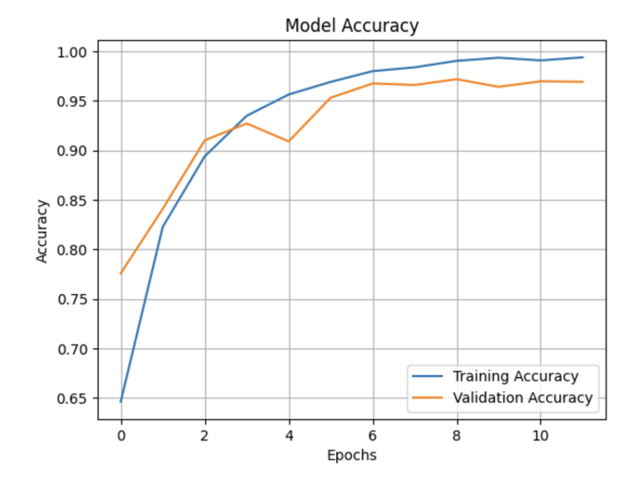

Figure 8: Model Accuracy

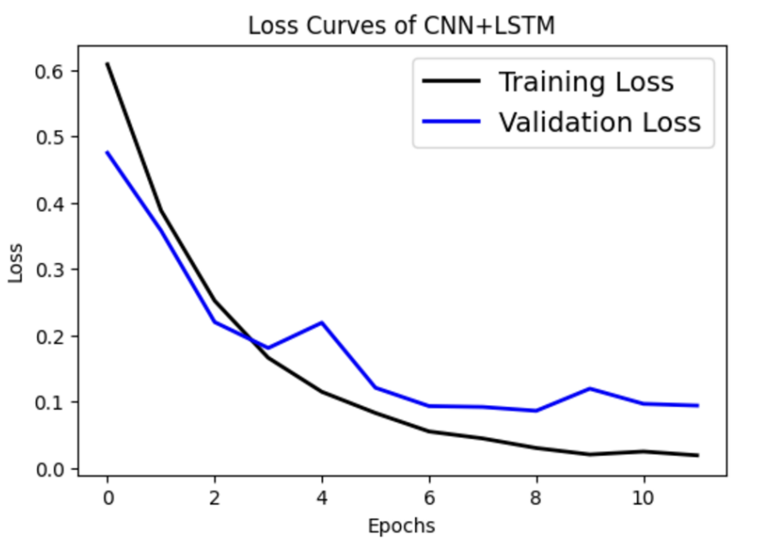

Figure 9: Loss Curves of CNN+LSTM

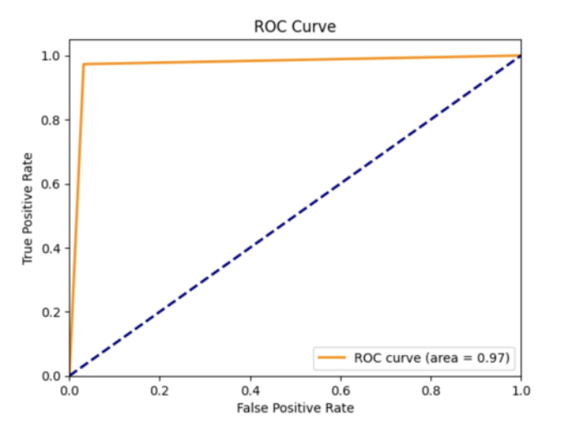

Figure 10 :ROC Curve

**Output**

Figure 11: Home Page

Figure 12: Our Services

**CHAPTER 5**

**CONCLUSION AND FUTURE SCOPE**

#### **5.1 Conclusion**

CrimeGuard is an advanced crime monitoring and analysis system that enhances public safety through real-time violence detection and predictive crime analytics. Utilizing Convolutional Neural Networks (CNNs) for visual recognition and Long Short-Term Memory (LSTM) networks for sequential data analysis, it accurately detects violent incidents and identifies high-risk crime areas based on historical patterns. By enabling timely intervention and proactive law enforcement strategies, CrimeGuard empowers authorities to mitigate threats effectively, ensuring safer communities through data-driven decision-making.

#### **5.2 Future Scope**

* Integration of Additional Data Sources
  + Utilize social media and IoT devices for improved threat detection.
* Reinforcement Learning
  + Enhance the system’s ability to adapt to evolving crime patterns.
* Incorporation of Socio-Economic Factors
  + Improve crime prediction accuracy by considering demographic and economic data.
* Algorithm Optimization & Cloud Integration
  + Ensure scalability and real-time performance using optimized algorithms and cloud infrastructure.
* Expansion of Dataset Diversity
  + Train the model on broader datasets to enhance detection accuracy for multiple types of violence.
* Edge Device Deployment
  + Enable real-time processing by deploying the model on edge devices.

These advancements will **enhance CrimeGuard’s efficiency, scalability, and real-world applicability**.

**REFERENCES**

[1] M. Sabokrou, M. Fathy, M. Hoseini, and R. Klette, “Deep-anomaly: Fully convolutional neural network for fast anomaly detection in crowded scenes,” Computer Vision and Image Understanding, vol. 172, pp. 88-97, 2018.

[2] B. Sathyadevan and S. Gangadharan, “Crime analysis and prediction using data mining techniques,” 2014 First International Conference on Networks & Soft Computing (ICNSC), 2014, pp. 406-412.

[3] M. Ullah, M. A. Muhammad, G. H. Lee, and S. W. Baik, “Violence detection using spatiotemporal features with 3D convolutional neural networks,” Sensors, vol. 19, no. 11, p. 2472, 2019.

[4] A. Adadi and M. Berrada, “Peeking inside the black-box: A survey on explainable artificial intelligence (XAI),” IEEE Access, vol. 6, pp. 52138-52160, 2018.

[5] X. Xu, L. Yang, H. Wang, and F. Zhao, “Edge computing: A new computing model for Internet of Things,” IEEE Internet of Things Journal, vol. 7, no. 3, pp. 1778-1786, 2020.

[6] N. K. Sharma, M. Pandey, and R. K. Gupta, “IoT-based smart surveillance systems for crime detection and prevention,” Journal of Ambient Intelligence and Humanized Computing, vol. 12, pp. 8473-8490, 2021.

[7] G. Gorr and R. Harries, “Introduction to crime forecasting,” International Journal of Forecasting, vol. 19, no. 4, pp. 551-555, 2003.